Unit 6 | Data and Statistics Review |  | Name:________________________________  Hr:_________ Date:_____________________

Use the data in the table to answer questions 1 - 6.

The table shows the amount of money 15 people spent on a ticket to the Cardinals game.
Amount Spent ($) | $30 | $35 | $40 | $45 | $50
Number of People | 1 | 3 | 2 | 5 | 4

- Graph the data in a line plot.

- Find the modal amount spent per person (mode). __________________________

- Find the range of the data. __________________________

- Find the median of the amount spent per person. __________________________

- Find the mean amount spent per person. __________________________

6. The table below shows the heights (in inches) of 15 students.

54 | 56 | 56 | 61 | 62 | 65 | 65 | 68 | 69 | 72 | 75 | 75 | 77 | 80 | 81

Complete the frequency table.

Height (in.) | Tally | Frequency
50-59
60-69
70-79
80-89

Use the frequency table to draw a histogram.

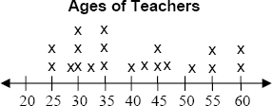

7. Find the mode and range from the line plot.
Mode: ________

Range: ________

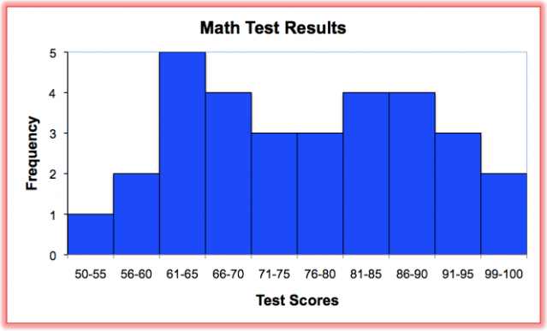

8. Can you use this histogram to determine how many students scored exactly an 83% on the test? Explain why or why not.

______________________________________________________________________________

______________________________________________________________________________

______________________________________________________________________________

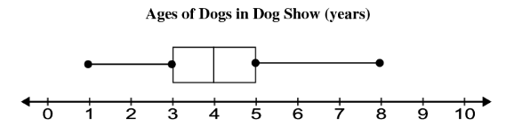

9. Use the box-and-whisker plot to identify the: Median: ______

Lower extreme: ______ Upper extreme: ______

Lower quartile: ______ Upper quartile: ______

